### A Gesture-Based Tool For Sterile Browsing Of Radiology Images Using IBM Watson

**1. INTRODUCTION**

**1.1 Overview**

Humans are able to recognize body and sign language easily. This is possible due to the combination of vision and synaptic interactions that were formed along brain development . In order to replicate this skill in computers, some problems need to be solved: how to separate objects of interest in images and which image capture technology and classification technique are more appropriate, among others.

In this project Gesture based Desktop automation ,First the model is trained pre trained on the images of different hand gestures, such as a showing numbers with fingers as 1 ,2,3,4 . This model uses the integrated webcam to capture the video frame. The image of the gesture captured in the video frame is compared with  the Pre-trained model and the gesture is identified. If the gesture predictes is 1 then images is blurred;2, image is resized;3,image is rotated etc.

**1.2 Purpose**

It is used to browse through the images obtained using radiology using hand gestures rather than using mouse,keyboard,etc thereby maintaining sterility.

**2. LITERATURE SURVEY**

**2.1 Existing problem**

Humans are able to recognize body and sign language easily. This is possible due to the combination of vision and synaptic interactions that were formed along brain development . In order to replicate this skill in computers, some problems need to be solved: how to separate objects of interest in images and which image capture technology and classification technique are more appropriate, among others.

**2.2 Proposed solution**

It is used to browse through the images obtained using radiology using hand gestures rather than using mouse,keyboard,etc thereby maintaining sterility.

**3. THEORITICAL ANALYSIS**

**3.1 Block Diagram**

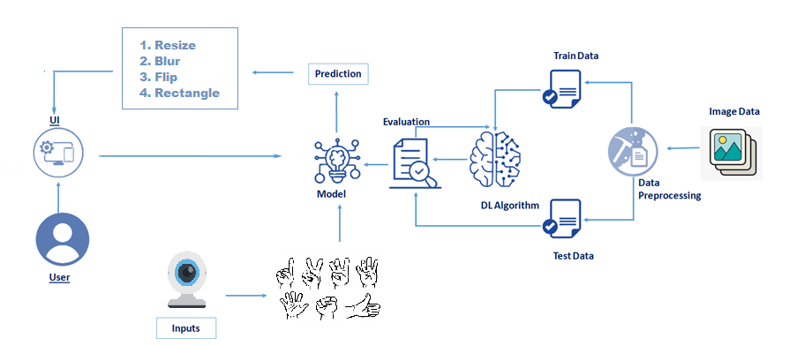

**3.2 Hardware / Software designing**

***Software Requirements:***

* Anaconda Navigator
* Tensor flow
* Keras
* Flask

***Hardware Requirements:***

* Processor              : Intel Core i3
* Hard Disk Space   : Min 100 GB
* Ram                        : 4 GB
* Display                  : 14.1 “Color Monitor(LCD, CRT or LED)

Clock Speed         : 1.67 GHz

**4. EXPERIMENTAL INVESTIGATIONS**

* User interacts with the UI (User Interface) to upload the image as input
* Depending on the different gesture inputs different operations are applied to the input image.
* Once model analyses the gesture, the prediction with operation applied on image is showcased on the UI.

**5. FLOWCHART**

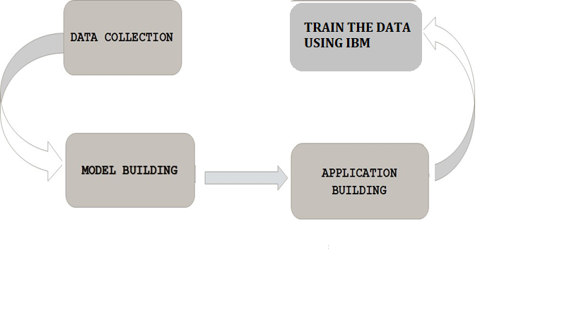

**6. RESULT**

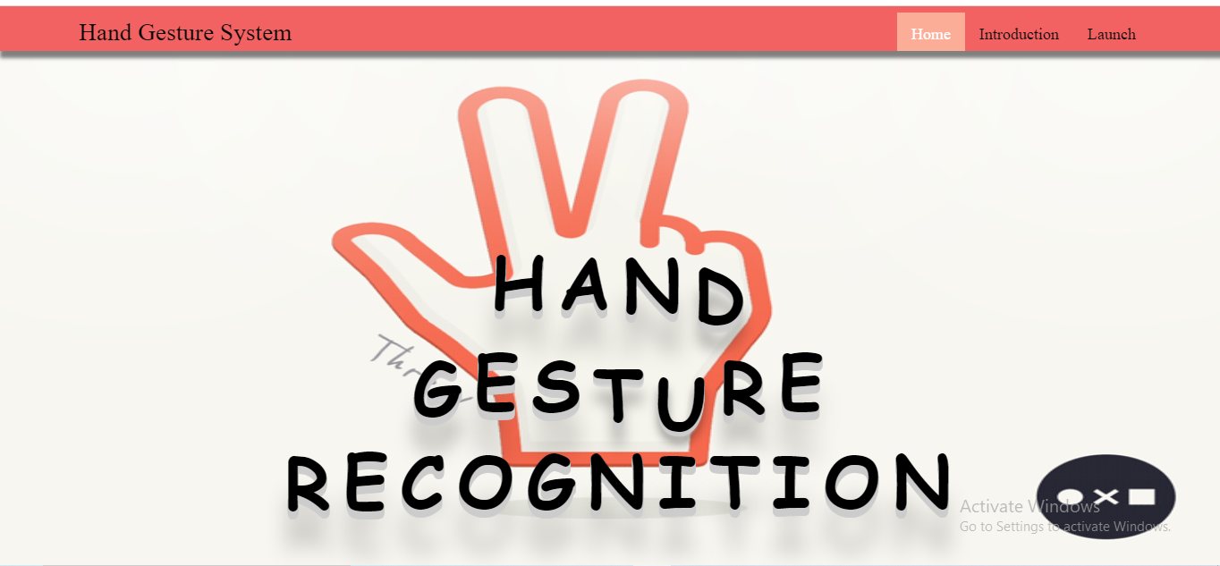

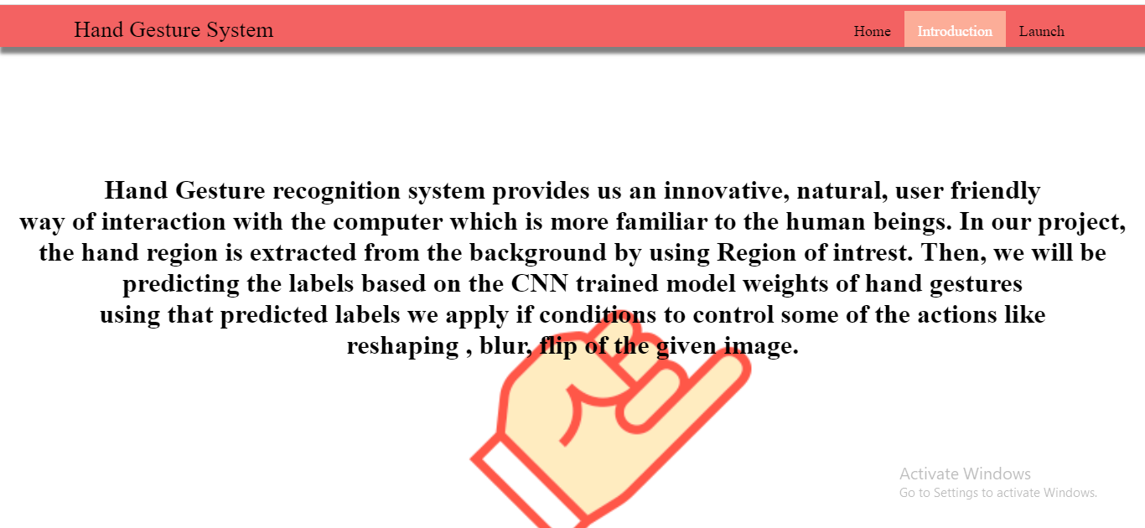

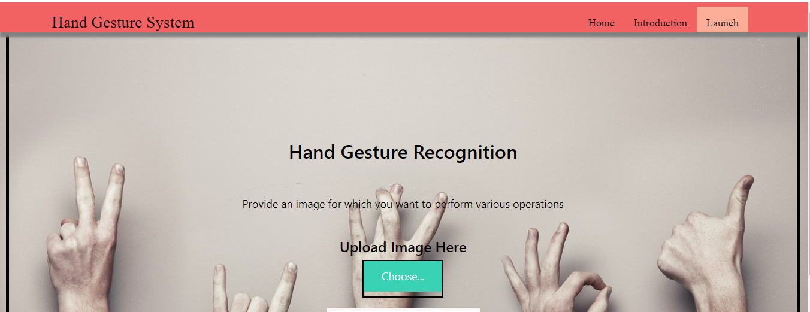

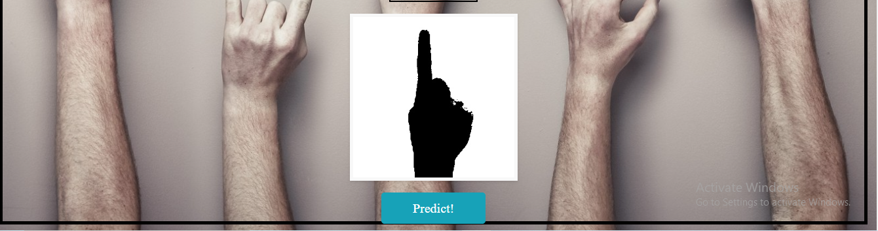

**7. ADVANTAGES & DISADVANTAGES**

***Advantages:***

* know fundamental concepts and techniques of Convolutional Neural Network.
* gain a broad understanding of image data.
* Know how to pre-process/clean the data using different data preprocessing techniques.
* know how to build a web application using Flask framework.

***Disadvantages:***

The tool can be quite expensive as it requires cameras and other expensive devices to capture images and process it.

**8. APPLICATIONS**

* This hand based gesture tool developed can be mainly used in the medical industry to browse images without compromising the sterility.
* However it can also be used in different industries while presenting certain ideas, during meetings, and can be used by teachers while teaching..

**9. CONCLUSION**

In this project, we have established the application for a gesture-based tool for sterile browsing of radiology images using IBM. Humans are able to recognize body and sign language easily. This tool is also easy to use and is quicker than the regular method of using mouse/keyboard. It also does not require the user to have any device on them to use it.

**10. FUTURE SCOPE**

* The tool can be made quicker by increasing the recognition speed.
* More number of gestures can be added thereby increasing this tool’s functionality and useability for different purposes.
* Tracking of both hands can be added to increase the set of commands. Voice commands can also be added to further increase the functionality.

**11. BIBILOGRAPHY**

[A gesture-based tool for sterile browsing of radiology images - PubMed (nih.gov)](https://pubmed.ncbi.nlm.nih.gov/18451034/)

<https://github.com/Guided-Projects/University_Admission_Prediction>

<https://www.ncbi.nlm.nih.gov/pmc/articles/PMC2410001/>

Smartinternz Website: https://smartinternz.com/Student/guided_project_info/319049#

**APPENDIX**

**Source Code**

